To Whom It May Concern

I consider myself to be an unconventional scientist, which is the reason why I have decided to first describe the factors that not only pertain to my persona, but have highly shaped my core-values. Before I begin, I would like to emphasize that the factors that led me to become an engineer, computer and data scientist are embedded in my nature and have contributed to my overall success. This is the reason why I am first introducing what defines me as a person prior to elaborating on my advanced academic success and extensive professional experience.

There are three factors that define my persona and core values:
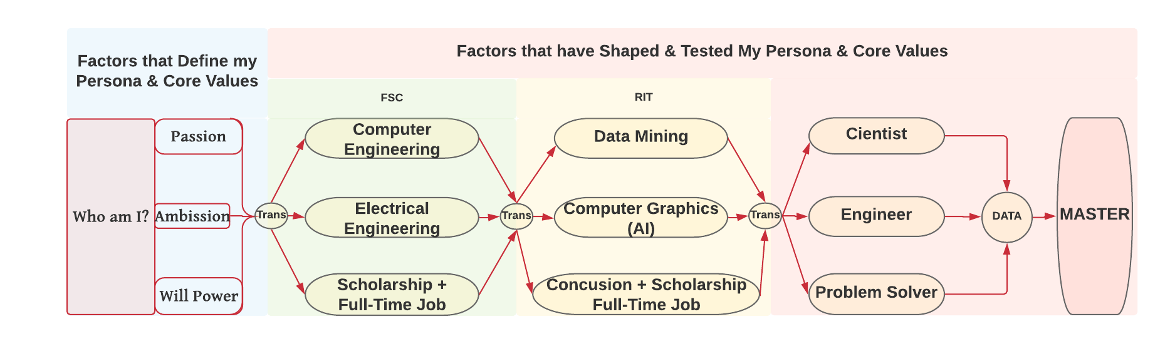
- Ambition, to make a positive-impact in our society and better myself. This led me to my electrical engineer BS at Farmingdale State College(FSC) and my Computer Graphics(AI) major, MS in Computer Science, at Rochester Institute of Technology(RIT).
- Passion, to pursue what I love. This led me to pursue another BS degree, Computer Engineer, at FSC, and another degree, in Data Mining, at RIT.
- Will power. This helped me break through barriers to pursue my ambition and my passion while having:
  - A full-time job, dual degree, and maintaining above average score to keep full-time scholarship at FSC.
  - A concussion, full-time job, two degrees, and maintaining above average score to keep scholarship at RIT.

In few words, I am ambitious, very passionate, and relentless towards my goals. These factors have defined my persona and core-values throughout my years, and have been the powersource of my overall success.
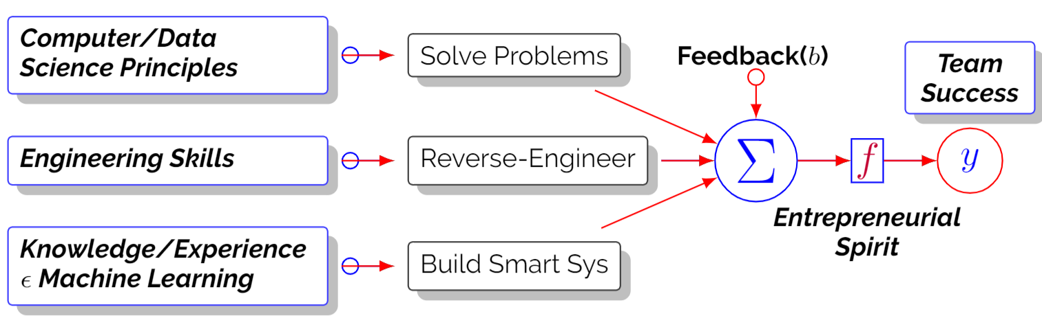
I consider myself to be unconventional because I love engineering, computer and data science. But, I am wholeheartedly devoted to data science and machine learning. Professionally, I have demonstrated my entrepreneurial spirit by contributing to the overall success of my team implementing:
- Computer/Data Science principles to solve problems, create/improve processes, avoid mistakes and deliver.
- Engineering skills to fix, build, automate, and reverse-engineer tools to facilitate and automate daily tasks.
- Knowledge/Experience in Machine Learning to build the right infrastructure for big data and smart systems.
More importantly, I use my experience as a feedback to improve and grow, along with my team, professionally.

Overall, I am not a perfect scientist, engineer or problem solver. However, I have the ability to master each, or all, of these aspects of my field within a specific focus - I chose Data. As a professional, not only do I bring my experiences and skills, but also my persona to a) take the team’s goals as career ambitions, b) passionately lead/contribute in the development of data tools and smart systems to improve performance/expand within the industry, and c) use my will power to help the team overcome obstacles and achieve goals in a timely manner.

Sincerely,
Piter Garcia

